Approve RFA

- Open RFA Approval screen by using transaction: ZMFM050061

- Enter you user ID in the Buyer field (Optional) and the RFQ number in the RFQ No. field(optional)
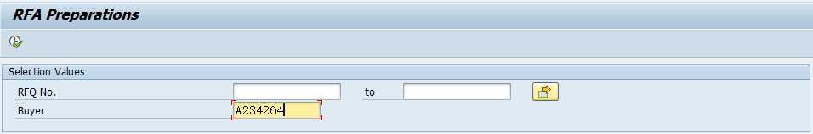

- Press

- A list of all RFA ‘s waiting for approval appears:

- You can input comment when you approve or reject by clicking
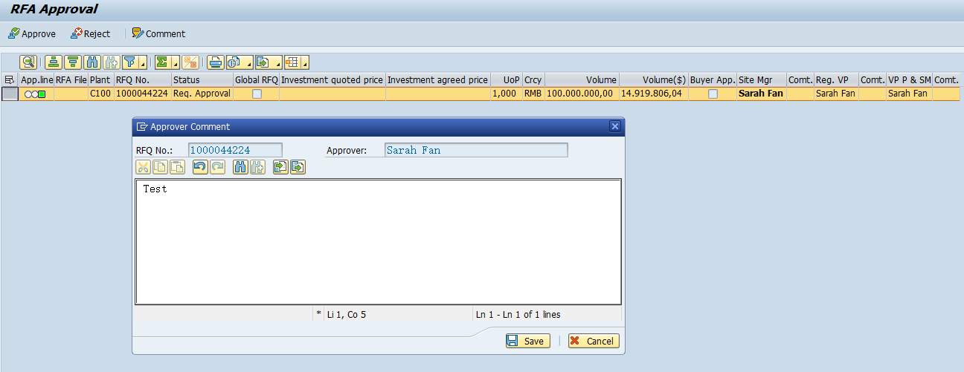


- Click for approval and click for reject

If RFA is rejected for all plants. The status changes to “Return” and the RFQ is open for quotation again in VIVA.
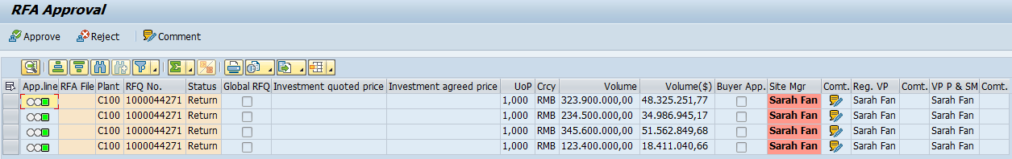
An email notification is sent to buyer and supplier:
If RFQ is global and the RFA is rejected for one of the plants, the status changes to “On Hold”
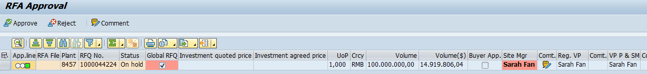
In case of RFQ “On hold” and email notification is sent to the buyer:

